Beyond Tokenization: Spelling Perturbations, Explanation Stability and Faithfulness in Devanagari D-SAFE

1st Ananya Sharma
Dept.of CSE(AI)
KIET Deemed to be University
Ghaziabad, India
ananyasharma0286@gmail.com
2nd Aneka Srivastava
Dept. of CSE(AI)
KIET Deemed to be University
Ghaziabad, India
aneka7216@gmail.com
3rd Aastha Srivastava
Dept. of CSE(AI)
KIET Deemed to be Unversity
Ghaziabad, India
aasthasrivastava210@gmail.com

4th Aastha
Dept. of CSE(AI)
KIET Deemed to be University
Ghaziabad, India
aasthahcs05@gmail.com
5th Anchal Rai
Dept. ofCSE(AI)
KIET Deemed to be University
Ghaziabad, India
anchalrai3008@gmail.com
6th Bikki Kumar
Dept. of CSE(AI)
KIET Deemed to be University
Ghaziabad, India
bikkikumar@gmail.co

Abstract— Pretrained language models can answer in ways when small lexical changes happen but the effects of spelling perturbations on tokenization on model predictability and on explanation quality are still important questions for Hindi natural language processing. D-SAFE looks at these effects in Devanagari Hindi with two pretrained masked language models, MuRIL and XLM‑RoBERTa. The evaluation dataset has 2000 sentence pairs in three tracks: valid‑word context, synonym substitution and realistic spelling‑error. The experimental pipeline checks target‑word subword fragmentation, pseudo‑log‑likelihood for predictability and token‑level explanations from Attention and Integrated Gradients. Explanation stability is checked with rank correlation and faithfulness is tested by masking parts of the context and watching changes in the target logit. In the 1,280‑pair spelling‑error subset single‑subword target coverage drops from 90 percent to 30 percent for MuRIL and from 70 percent to 20 percent for XLM‑RoBERTa. The average log‑probability difference for spelling contrasts is more negative for MuRIL than for XLM‑RoBERTa. Attention gives higher mean explanation‑rank stability than Integrated Gradients in both models under this setup. However, the exploratory tests between stability and faithfulness do not find a significant link, for any model‑method pair. These findings show that explanation stability should not automatically mean that faithfulness is guaranteed. The results are limited by the small spelling‑error subset and by the limits of masking‑based evaluation, larger datasets and extra faithfulness tests are needed.
Index Terms— Hindi natural language processing, lexical perturbation, subword tokenization, masked language models, explainable artificial intelligence, explanation stability, explanation faithfulness, Integrated Gradients.

Introduction
Pretrained language models are a foundation for natural language processing they learns representations from large collections of text. However can be sensitive to changes in the input. The pretrained model reacts to substitutions and spelling variations. The sensitivity is very important for languages that use scripts such as Devanagari, a small orthographic change can affect tokenization and the representation of a target word. Subword tokenization lets the model process words that're not full entries in its vocabulary, a spelling variation can cause a word to be split into a number of subword tokens. These changes can affect the inputs that model uses for prediction. Measuring tokenization differences is therefore a first step for studying the pretrained model’s behavior under lexical perturbations, second challenge is how to interpret the pretrained language model’s behavior. A change in score can signal a difference in its relative predictability assessment, it does not directly prove grammatical correctness or semantic equivalence. In D-SAFE pseudo-log-likelihood-based scoring is used to compare the predictability of contrast targets. The analysis keeps the pretrained model’s scores separate from judgments about language acceptability. Attention and Integrated Gradients are two methods used to derive token-level importance estimates. These methods rely on computational signals. An explanation may stay similar when the input changes. However stability does not prove that the explanation faithfully represents the factors that influence the pretrained model’s output. Stability and faithfulness must therefore be evaluated as properties. D-SAFE explores the issues in Devanagari Hindi with the pretrained models MuRIL and XLM‑RoBERTa. A curated dataset of 2000 sentence pairs is arranged into three tracks: valid-word context, synonym substitution and realistic spelling-error. The experimental pipeline looks at target word tokenization, pseudo-log-likelihood-based predictability, explanation stability and masking-based faithfulness. First , characterizes changes in target-word subword coverage when spelling perturbations occur in the pretrained language models MuRIL and XLM‑RoBERTa. Second, compares model-based predictability scores and the behavior of Attention and Integrated Gradients under chosen perturbations. Third, it evaluates the relationship between explanation stability and a masking-based faithfulness measure making it clear that the results are observational than universal or causal The findings aim to provide an analysis of lexical sensitivity and explanation evaluation in Hindi. The small spelling-error subset, the need for target alignment and the limits of masking interventions restrict the conclusions. These limits are taken into account when the study interprets the results and suggests paths, for research.
- Hindi sentence-pair resource: We assemble and audit a 2000-pair Devanagari Hindi dataset covering valid-word contextual contrasts, synonym substitutions, and realistic spelling errors.
- Tokenization and PLL measurements: We compare target-word fragmentation and pseudo-log-likelihood changes across XLM-RoBERTa and MuRIL.
- Explanation evaluation protocol: We document a visible-target scoring protocol and exploratory attention and Integrated-Gradients-based stability and faithfulness analyses, including eligibility restrictions and methodological artefacts.
- Exploratory stability–faithfulness result: We report that no statistically significant association was detected between the examined stability and faithfulness measures in the current small-sample evaluation.

RELATED WORK

Subword Tokenization and Lexical Robustness
Subword vocabularies allow pretrained models to show words but how well a language is covered depends on the tokenizer. Rust et al. Compared models with monolingual models and found that a special monolingual tokenizer matters about as much as pretraining data size; replacing a multilingual models tokenizer with a special one improved downstream performance for almost every task and language they tested. XLM-RoBERTa shares one vocabulary across languages whereas MuRIL was built with an emphasis on Indian languages. For Hindi Ravikiran et al. Checked Indic-focused and byte-level tokenizers on informal expressions and found that Indic-oriented models such as MuRIL keep expression boundaries better than general multilingual models while all tokenizers have problems under romanization. Aliakbarzadeh et al. Collected typos from Wikipedia edit histories for six languages, including Hindi and tested nine models on natural language inference, named entity recognition and intent classification; every model had lower accuracy on noisy test data with average differences of 2.3 to 4.3 percentage points. These studies look at accuracy or boundary preservation. We instead look at how a controlled Devanagari spelling change changes the subword segmentation of a target word and link that change to model scoring and to explanations.

Masked Language Models and Pseudo-Log-Likelihood
A masked language model does not create a left-to-right sequence probability. Salazar et al. Introduced pseudo-log-likelihood (PLL) which masks each token one by one and adds the log-probabilities. They showed that PLL scores are better than scores from models on several tasks and said this is because of an unsupervised expression of linguistic acceptability. Kauf and Ivanova later found that the original PLL gives scores to out-of-vocabulary words that are split into several tokens and suggested PLL-word-l2r, which also masks the within-word tokens to the right of the target. They also showed that the choice of changes results on minimal-pair benchmarks. This is important here because spelling variants tend to be split into more subword tokens. We use the PLL with length normalization compare scores only inside a model and see them as a measure of model predictability instead of grammaticality or human acceptability. The inflation mentioned in means our scores for variants might not show their full penalty.

Explanation Stability and Faithfulness
Faithfulness means whether the features an explanation shows actually changed the models output. Jacovi and Goldberg talk about how faithfulness should be defined and tested and ERASER makes it clear through comprehensiveness and sufficiency which look at how a prediction changes when rationale tokens are removed or kept. Madsen et al. Mask what they think are tokens again and again and retrain the model and compare against random masking. Our k, bottom-k and random-k masking follows the same comparison idea but does not retrain so our masked inputs might not be in the models training distribution. Stability means whether explanations stay the same with input changes. Yin et al. Suggested sensitivity and stability as criteria that go with removal-based faithfulness and showed that conclusions about faithfulness can change with the criteria used. Agarwal et al. [18] Introduced Relative Stability metrics and showed that several popular explanation methods are unstable. Of saying a stable explanation is faithful we check both on the same sentences and see if they are connected.

Dataset and Methodology

Dataset
- The study uses a curated dataset stored in an Excel file that contains 2000 sentence pairs and 18 columns. The pairs are split into three tracks: VALID_WORD_CONTEXT with 322 pairs SYNONYM_SUBSTITUTION with 398 pairs and REALISTIC_SPELLING_ERROR with 1,280 pairs. The dataset holds contrast sentences, target words, meanings in Hindi and English grammaticality marks contrast labels, notes, annotation fields, final status and source details.
- A structural validation report shows that all expected columns exist every one of the 2000 rows is not empty no duplicate pair identifiers were found no required fields are missing and no identical sentence pairs appear. The report records 1999 accepted pairs and one rejected pair. It also finds six inconsistencies, between annotator or adjudication labels and final status. Those cases need review before the dataset can be called fully annotation-validated.
- The spelling-error track contains 1,280 pairs. Therefore results specific to spelling perturbations should be seen as exploratory. Should not be assumed to represent all forms of Hindi spelling variation.

Models
- Let T (w) denote the number of subword tokens that are used to represent the target word w.
- For a pair that consists of a form wo and a perturbed form wp, the token-count change is defined by the equation ∆T equals
$$∆T = T \left(wp\right)- T \left(wo\right) \left(1\right)$$
- If the value is positive it indicates that the perturbed target uses more subword tokens.
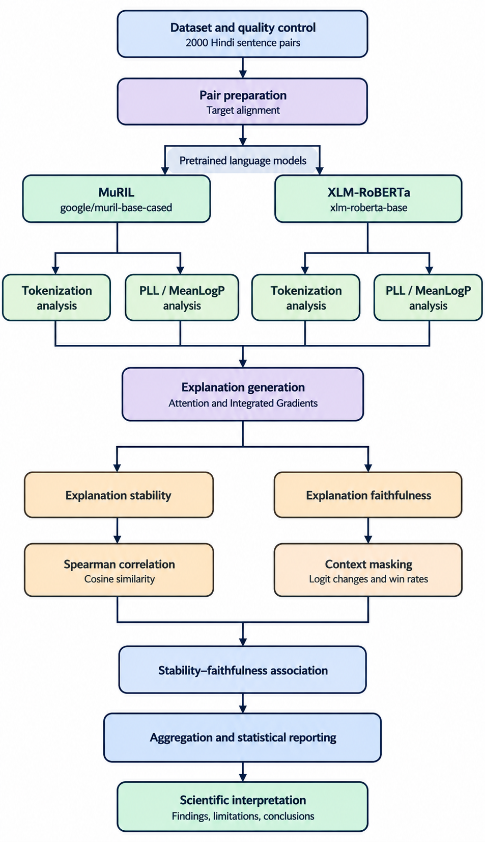
- Single-subword coverage is the proportion of target words that are represented by one subword token.

Pseudo-Log-Likelihood
For a tokenized sequence x = (x1, . . . , xn), pseudo‑log‑likelihood is calculated by masking each token one at a time and then computing its log‑probability:
$$\text{PLL}\left(x\right)=\sum_{i=1}^{n}{\log{P}}\left(x_{i}∣x_{∖i}\right) (2)$$
where $x_{∖i}$ denotes the sequence with token $x_{i}$ masked. For comparisons across sequences of different token lengths, we also use mean token log-probability:
$$\text{MeanLogP}\left(x\right)=\frac{\text{PLL}\left(x\right)}{n} (3)$$
The difference between the contrast sentence and the original sentence is called $ΔS$, and is defined as:
$$ΔS=\text{MeanLogP}\left(x_{\text{p}}\right)-\text{MeanLogP}\left(x_{\text{o}}\right) (4)$$
If $ΔS$ is negative, that means the perturbed or contrast sentence has a lower average token log-probability according to the model. This does not, on its own, prove that the sentence is ungrammatical or semantically wrong.

Explanation Method
We look at two ways to explain what the model does.
- Attention: we use the attention weights from the transformer layer to say how important each token is.
- Integrated Gradients (IG): we find importance by adding up gradients along a path that starts from a baseline representation and ends at the real input. For IG we use a PAD‑based context baseline. Do 20 integration steps. We keep the target score and the rule for matching tokens to words the same for both the original and the altered sentences.

Visible-Target Scoring
In the experiments that test faithfulness we let the target word stay visible. We hide some context words. When the target word is made up of subword tokens we compute its score by averaging the unnormalised logits for each subword token:
$$s\left(x,w\right)=\frac{1}{|I_{w}|}\sum_{i∈I_{w}}{z_{i}}\left(x\right) (5)$$
Where $I_{w}$ is the set of subword positions corresponding to the target, and $z_{i}\left(x\right)$ is the target-token logit at position $i$. This operational scoring choice is not a calibrated probability; however, the multi-subword protocol permits scoring a larger set of pairs. Conversely, the strict single-subword protocol is reserved for analyses that require unambiguous target alignment.

Faithfulness Interventions
For each sentence we test three types of masking: we hide the important context tokens we hide the least important context tokens and we hide a random set of context tokens. We hide 10 %, 20 % or 30 % of the tokens. For a chosen intervention we calculate the logit drop as
$$\begin{aligned}D=s\left(x,w\right)-s\left(x_{\text{masked}},w\right)\end{aligned} (6)$$
If D is positive the target score goes down after masking; if D is negative it goes up. We then compute the faithfulness gap between top‑ and bottom‑masking as
$$\begin{aligned}G=D_{\text{top}}-D_{\text{bottom} }\end{aligned} (7)$$
If G is positive masking the top tokens hurts the score more than masking the tokens. This comparison tells us something about the model. It does not prove a causal link because masking can create inputs that do not normally appear in the data.

Explanation Stability
We check how stable the explanations are by comparing token‑level attributions between the sentence and a version with spelling mistakes after lining up the same context tokens. We use rank‑based correlation and cosine similarity to measure this. A serious problem, with the protocol shows up: if we hide the target word in both sentences the spelling difference disappears at that spot. The rest of the sentence can then be the same or almost the same. Seeing stability in that situation is just a trick of the experiment and does not mean the explanations are truly robust.

Results
TABLE III
SINGLE-SUBWORD COVERAGE FOR SPELLING PAIRS
Model | Original | Perturbed | Change
MuRIL | 90% | 30% | −60 pp
XLM-RoBERTa | 70% | 20% | −50 pp

Coverage is the share of target words represented by exactly one subword token (N = 1280 pairs per model). pp = percentage points.

Subword Fragmentation
The tokenization analysis shows that small spelling changes can lead to fragmentation of the target word .Table III gives a summary of how the target word appears as a single subword, in the spelling subset .These results are based on 1280 spelling pairs .They show that minor spelling differences can change how subwords are split in both models .These results should not be applied to all Hindi words or all kinds of spelling variations.
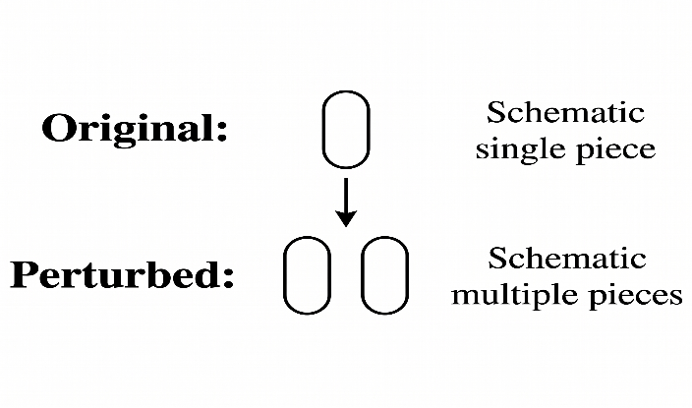

Fig 1. Schematic illustrations of a possible segmentation change for and the spelling variant.

Illustrative Tokenization Example
Figure 1 shows the kind of segmentation change that Tokenization examined in this work.
The token boundaries shown are drawings; the exact subword pieces must be swapped with the tokenizer outputs recorded for the chosen example.
TABLE IV
MEAN ΔS BY MODEL AND PAIR CATEGORY
Model | Category | Mean ΔS
XLM-RoBERTa | Valid-word context | −1.0933
XLM-RoBERTa | Synonym substitution | −0.0655
XLM-RoBERTa | Spelling error | −0.6695
MuRIL | Valid-word context | −1.9141
MuRIL | Synonym substitution | −0.5810
MuRIL | Spelling error | −2.0368
ΔS = MeanLogP(contrast) − MeanLogP(original). Negative values mean the contrast sentence received a lower mean token log-probability. Pairs: 142 valid-word context, 38 synonym substitution, 1280 spelling error.

Pseudo-Log-Likelihood
Table IV reports the average difference between the contrast sentence and the original MeanLogP. Negative values mean that the contrast sentence has a mean token log-probability. In the spelling category the average difference is negative for both models. The difference is larger for MuRIL. However the pattern changes across categories and, across the two models. These results describe how the models score sentences and they should not be taken as measurements of grammaticality or human understanding.
TABLE V
POOLED EXPLANATION STABILITY
Model | Method | Mean rank ρ | Mean cosine
XLM-RoBERTa | Attention | 0.7425 | 0.9648
XLM-RoBERTa | IG | 0.3589 | 0.8994
MuRIL | Attention | 0.7043 | 0.9639
MuRIL | IG | 0.2632 | 0.9880

Explanation Stability
The stability analysis includes 1280 spelling pairs per model and method in the analysis. Under the alignment protocol the pooled mean rank correlation and mean cosine similarity are summarised in Table V.
Attention-based explanations show higher pooled mean rank correlations than IG in this particular analysis. These descriptive results should be interpreted alongside the target-masking artefact and the alignment protocol. In particular a high stability score does not establish that the explanation is faithful.
For the single-subword target protocol only 4 XLM-RoBERTa pairs and 6 MuRIL pairs were eligible. The subset results therefore have substantially less coverage, than the pooled stability analysis.
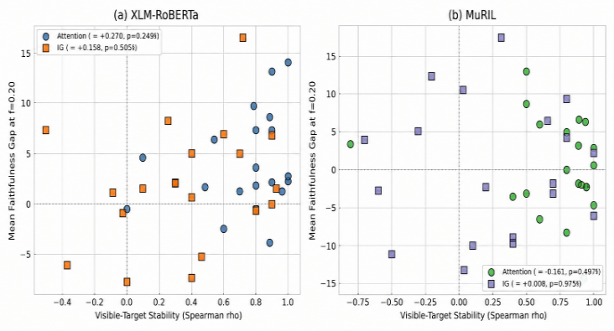
TABLE VI
FAITHFULNESS INTERVENTION SUMMARY
Model | Method | Mean gap | Win rate
XLM-RoBERTa | Attention | 4.40 | 76.7%
XLM-RoBERTa | IG | 2.32 | 58.3%
MuRIL | Attention | 2.21 | 63.3%
MuRIL | IG | −0.45 | 44.2%

Averaged over masking fractions of 10%, 20% and 30%; N = 40 sentences per fraction (20 pairs × 2). Gap = D_{top} − D_{bottom}; win rate = share of sentences with D_{top} > D_{bottom}. IG = Integrated Gradients.

Faithfulness Intervention Results
Table VI summarizes the top-versus-bottom faithfulness gaps and the proportion of evaluations in which the top-ranked masking intervention produced a larger logit drop. The values include the 10%, 20% and 30% masking fractions.
The table combines the reported gaps across the three masking fractions. The win rate is the proportion of sentence-level evaluations where Dtop's greater than Dbottom. Small differences in these values can happen because of rounding. The final values should be created directly from the faithfulness summary CSV before submitting.
The XLM-RoBERTa attention condition has an average gap and a higher win rate than the other conditions. For MuRIL with IG the aggregate gap is slightly negative. The win rate is less, than 50%. These results are exploratory. Do not prove that one explanation method is always more faithful. The intervention changes the input distribution and masking effects can vary based on the model, sentence and masking fraction.
TABLE VII
STABILITY–FAITHFULNESS CORRELATIONS
Model | Method | Spearman ρ |  | p-value
XLM-RoBERTa | Attention | 0.2704 |  | 0.2490
XLM-RoBERTa | IG | 0.1583 |  | 0.5052
MuRIL | Attention | −0.1611 |  | 0.4974
MuRIL | IG | 0.0075 |  | 0.9749

Spearman correlation between visible-target stability and the mean faithfulness gap at a masking fraction of f = 0.20; N = 200 spelling pairs per model and method. None of the correlations is significant at p < .05. IG = Integrated Gradients.
Fig. 2. Shows the relationship between visible‑target explanation stability (Spearman ρ) and the mean faithfulness gap when 20 % of the context is masked for (a) XLM‑RoBERTa and (b) MuRIL. Each dot represents one spelling pair (1280 pairs for each model and method). Circles denote Attention squares denote Integrated Gradients (IG). The legend gives the Spearman correlation and p‑value for each model–method pair; none of these is significant, at p < .05.

Stability-Faithfulness Relationship
We examine the connection between explanation stability and faithfulness gap using Spearman rank correlation. Table VII presents the exploratory results.
None of the four correlations achieves the standard p <.05 threshold. This means the analysis does not find a significant link, between the chosen stability measure and the faithfulness gap. However this does not prove that no relationship exists. The spelling subset is small the measurements contain noise. The outcome could depend on the specific explanation and intervention methods used.
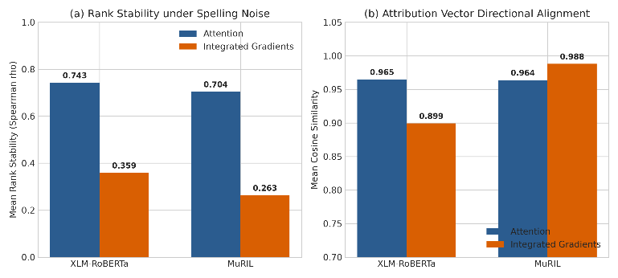
Fig. 3. Pooled explanation stability for 1280 spelling pairs per model. (A) Average Spearman rank correlation, between the perturbed attributions. (B) cosine similarity of the same attribution vectors; the y‑axis starts at 0.70. IG = Integrated Gradients.

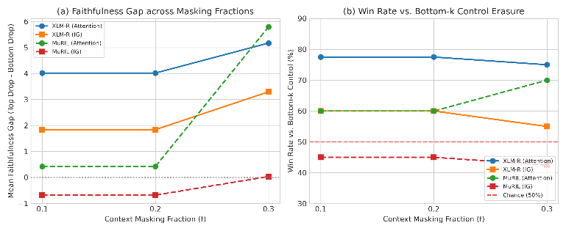
Fig. 4. Faithfulness across context masking fractions.(A) Mean faithfulness gap, calculated as the difference between the top‑k drop and the bottom‑k drop.(B) Win rate against bottom‑k masking; the dashed line indicates fifty percent.The ten percent and twenty percent fractions mask the number of tokens, on average (1.0) so their results match.

Visualising Stability and Faithfulness
Fig. 3 Provides an overview of the pooled stability results found in Table V. Panel (a) presents the mean rank correlation while panel (b) shows the mean cosine similarity between original and perturbed attributions. Attention achieves a mean rank correlation than IG for both models—0.743 versus 0.359 for XLM-RoBERTa and 0.704 versus 0.263 for MuRIL. However IG maintains a cosine similarity—0.899 for XLM-RoBERTa and 0.988 for MuRIL—even though its rank correlation is low. This indicates that the two measures reflect aspects of stability.
Fig. 4 Displays the faithfulness results across masking fractions. Panel (a) shows the mean faithfulness gap and panel (b) presents the win rate compared to bottom-k masking with 50% representing chance-level performance. For XLM-RoBERTa the attention gap is positive at all three masking fractions. The win rate remains between 75.0% and 77.5%. For MuRIL using IG the gap is negative at 10% and 20% masking and close to zero at 30% while the win rate stays under 50%. The results at 10% and 20% are identical since the average number of masked context tokens is 1.0, in both cases. Stability and faithfulness metrics have meanings, which is why they are shown separately. Their connection is explored in Fig. 2

DISCUSSION
The experiments show that changing spelling— slightly—can impact how a model breaks words into subwords and how it scores them. When there is a spelling mistake the model may use a different subword representation. This is clear from the drop in single-subword coverage. Also PLL measurements show that on average the contrast version minus the original gives scores for spelling changes.. The size of this drop varies between different models.
These findings make it important to look at explanation behavior separately from model scores. When we look at stability results attention-based attributions show fairly high rank stability.. High stability doesn’t mean the highlighted tokens truly reflect how the model makes its decision. The exploratory correlations don’t show any statistical link, between stability and faithfulness.
Several methodological points matter here. First PLL measures how predictable the model is, not whether the sentence is grammatically correct. Second masking context tokens can create inputs and this might actually raise the logit of the target instead of lowering it. Third the target-masked stability method might remove the spelling difference the study is trying to examine. Fourth the small spelling subset used limits how precise and generalizable the explanation results can be.

LIMITATIONS
Small explanation subset: Stability and faithfulness experiments use 1280 spelling pairs. The results are exploratory. Should be interpreted with caution.
Target alignment: Strict single-subword eligibility applies to 4 XLM-RoBERTa pairs and 6 MuRIL pairs. Using -subword scoring increases coverage but introduces a different aggregation choice that may affect interpretation.
Masking artefacts: Context masking can generate inputs that're out of distribution. Logit changes should not be seen as causal effects.
Stability protocol: Masking the target, in both sentences can remove the spelling perturbation leading to high stability scores.
Dataset scope: The dataset is constructed, not a representative sample of all Hindi spelling variation, dialects or real-world text.
Interpretation of PLL: Mean PLL does not directly measure grammaticality, semantic equivalence or human acceptability.

CONCLUSION AND FUTURE WORK
D-SAFE looked at how spelling changes affect Devanagari Hindi when using XLM-RoBERTa and MuRIL. The tokenization analysis showed that spelling variants often led to a drop in coverage for single-subword targets. The PLL differences varied depending on the model and the type of spelling pair. An exploratory analysis compared attention and Integrated Gradients using stability and mask-based faithfulness measures.
In the set of 1280 spelling pairs there was no statistically significant link, between stability and faithfulness. This does not mean stability and faithfulness are unrelated. It just means the result is inconclusive. The analysis also found a target-masking artifact. This artifact can make stability appear higher than it really is. Future experiments need to fix this issue.
Future work should include a larger spelling dataset. It should also improve the alignment of context to keep information consistent. The stability and faithfulness metrics should be pre-registered to avoid bias. Multiple attribution baselines should be compared to get a picture. Results should be validated using interventions that reduce distribution shift. Human judgments of acceptability could help separate model predictability from actual linguistic correctness.

References
- J. Salazar, D. Liang, T. Q. Nguyen, and K. Kirchhoff, "Masked language model scoring," in Proc. 58th Annu. Meeting Assoc. Comput. Linguistics (ACL), 2020, pp. 2699-2712.
- A. Conneau, K. Khandelwal, N. Goyal, V. Chaudhary, G. Wenzek, F. Guzman, E. Grave, M. Ott, L. Zettlemoyer, and V. Stoyanov, "Unsupervised cross-lingual representation learning at scale," in Proc. 58th Annu. Meeting Assoc. Comput. Linguistics (ACL), 2020, pp. 8440-8451.
- S. Khanuja et al., "MuRIL: Multilingual representations for Indian languages," arXiv:2103.10730, 2021.
- S. Jain and B. C. Wallace, "Attention is not explanation," in Proc. NAACL-HLT, 2019, pp. 3543-3556
- S. Wiegreffe and Y. Pinter, "Attention is not not explanation," in Proc. EMNLP-IJCNLP, 2019, pp. 11-20.
- M. Sundararajan, A. Taly, and Q. Yan, "Axiomatic attribution for deep networks," in Proc. 34th Int. Conf. Machine Learning (ICML), 2017, pp. 3319-3328.
- J. DeYoung, S. Jain, N. F. Rajani, E. Lehman, C. Xiong, R. Socher, and B. C. Wallace, "ERASER: A benchmark to evaluate rationalized NLP models," in Proc. 58th Annu. Meeting Assoc. Comput. Linguistics (ACL), 2020, pp. 4443-4458.
- A. Jacovi and Y. Goldberg, "Towards faithfully interpretable NLP systems: How should we define and evaluate faithfulness?" in Proc. 58th Annu. Meeting Assoc. Comput. Linguistics (ACL), 2020, pp. 4198-4205.
- A. Madsen, N. Meade, V. Adlakha, and S. Reddy, "Evaluating the faithfulness of importance measures in NLP by recursively masking allegedly important tokens and retraining," in Findings of the Assoc. Comput. Linguistics: EMNLP 2022, 2022.
- M. Ravikiran, T. Tiwari, V. Gupta, R. Prakash, R. Saluja, and S. Mohanty, "Do tokenizers fail on informal Hindi expressions? Evidence from static, downstream, and robustness analyses," in Proc. 2nd Workshop on Language Models for Low-Resource Languages (LoResLM), Rabat, Morocco, 2026, pp. 13-28.
- P. Rust, J. Pfeiffer, I. Vulic, S. Ruder, and I. Gurevych, "How good is your tokenizer? On the monolingual performance of multilingual language models," in Proc. 59th Annu. Meeting Assoc. Comput. Linguistics and 11th Int. Joint Conf. Natural Language Processing (ACL-IJCNLP), 2021.
- A. Aliakbarzadeh, L. Flek, and A. Karimi, "Exploring robustness of multilingual LLMs on real-world noisy data," arXiv:2501.08322, 2025.
- C. Kauf and A. Ivanova, "A better way to do masked language model scoring," in Proc. 61st Annu. Meeting Assoc. Comput. Linguistics (Vol. 2: Short Papers), 2023.
- F. Yin, Z. Shi, C.-J. Hsieh, and K.-W. Chang, "On the sensitivity and stability of model interpretations in NLP," in Proc. 60th Annu. Meeting Assoc. Comput. Linguistics (Vol. 1: Long Papers), 2022.
- C. Agarwal, N. Johnson, M. Pawelczyk, S. Krishna, E. Saxena, M. Zitnik, and H. Lakkaraju, "Rethinking stability for attribution-based explanations," arXiv:2203.06877, 2022.

